The points on the f(x) graph represent the parabolic function x2 = 4x1^2.

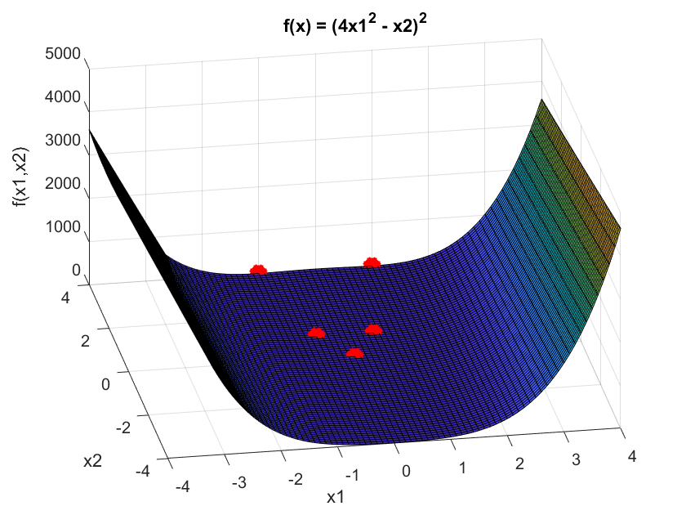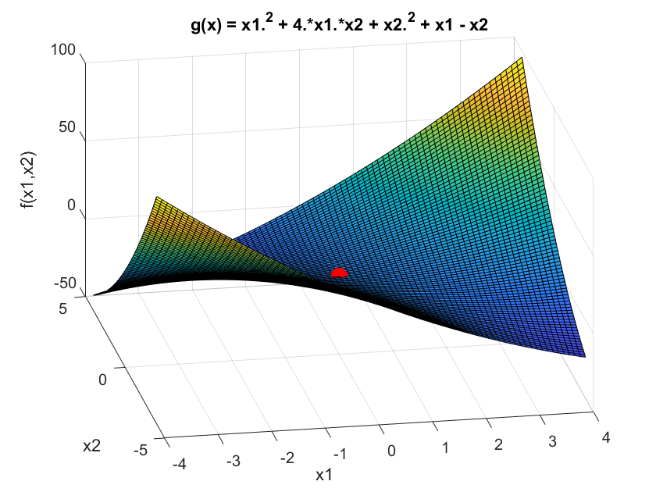

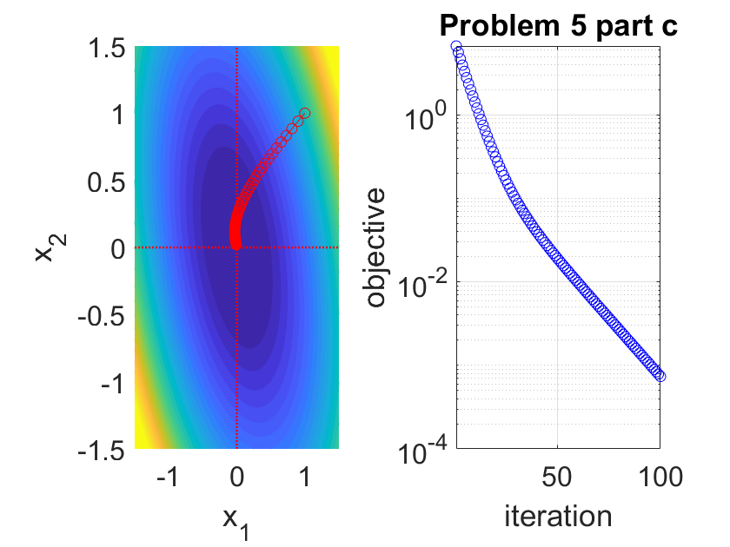

%%%%%%%%%%%%%%%%%%%%%%%%%%%%%%%%%%%%%%%%%%%%%%%%%%%%%%%%%%%%%%%%%%%%%%

% This script illustrates the gradient method (GM) for

% solving unconstrained optimization problems.

%

% This script uses "column vector" layout for vectors

% (as adopted in the lectures).

%

% U. S. Kamilov, CIG, WUSTL, 2020.

%%%%%%%%%%%%%%%%%%%%%%%%%%%%%%%%%%%%%%%%%%%%%%%%%%%%%%%%%%%%%%%%%%%%%%%%%%%

%% prepare workspace

%%%%%%%%%%%%%%%%%%%%%%%%%%%%%%%%%%%%%%%%%%%%%%%%%%%%%%%%%%%%%%%%%%%%%%%%%%%

clear; close all; home;

%%%%%%%%%%%%%%%%%%%%%%%%%%%%%%%%%%%%%%%%%%%%%%%%%%%%%%%%%%%%%%%%%%%%%%%%%%%

%% define the function and the gradient (*** to be completed ***)(done)

%%%%%%%%%%%%%%%%%%%%%%%%%%%%%%%%%%%%%%%%%%%%%%%%%%%%%%%%%%%%%%%%%%%%%%%%%%%

evaluateFunc = @(x1, x2) 4*x1.^2 + 2*x1.*x2 + 2*x2.^2;

evaluateGrad = @(x1, x2) [8*x1 + 2*x2; 2*x1 + 4*x2];

%%%%%%%%%%%%%%%%%%%%%%%%%%%%%%%%%%%%%%%%%%%%%%%%%%%%%%%%%%%%%%%%%%%%%%%%%%%

%% plot the contours of the function

%%%%%%%%%%%%%%%%%%%%%%%%%%%%%%%%%%%%%%%%%%%%%%%%%%%%%%%%%%%%%%%%%%%%%%%%%%%

figure('Color', 'w');

subplot(1, 2, 1);

fcontour(evaluateFunc, [-1.5, 1.5], 'Fill', 'on', 'LevelList', 0:0.5:15);

hold on;

plot([-1.5, 1.5], [0, 0], 'r:', 'LineWidth', 1.2)

plot([0, 0], [-1.5, 1.5], 'r:', 'LineWidth', 1.2)

xlabel('x_1');

ylabel('x_2');

set(gca, 'FontSize', 16);

%%%%%%%%%%%%%%%%%%%%%%%%%%%%%%%%%%%%%%%%%%%%%%%%%%%%%%%%%%%%%%%%%%%%%%%%%%%

%% parameters of the gradient method

%%%%%%%%%%%%%%%%%%%%%%%%%%%%%%%%%%%%%%%%%%%%%%%%%%%%%%%%%%%%%%%%%%%%%%%%%%%

xitInit = [1; 1]; % initialization

stepSize = 0.01; % step size

tol = 1e-6; % stopping tolerance

maxIter = 100; % maximum number of iterations

%%%%%%%%%%%%%%%%%%%%%%%%%%%%%%%%%%%%%%%%%%%%%%%%%%%%%%%%%%%%%%%%%%%%%%%%%%%

%% optimize

%%%%%%%%%%%%%%%%%%%%%%%%%%%%%%%%%%%%%%%%%%%%%%%%%%%%%%%%%%%%%%%%%%%%%%%%%%%

% initialize

xit = xitInit;

% iterate

for iter = 1:maxIter

% compute the next iterate (*** to be completed ***)(Done)

xitNext = xit - stepSize.*evaluateGrad(xit(1),xit(2));

% plot the objective and the iterate evolution

subplot(1, 2, 1);

plot([xit(1), xitNext(1)], [xit(2), xitNext(2)], 'ro-');

hold on;

subplot(1, 2, 2);

semilogy(iter, evaluateFunc(xitNext(1), xitNext(2)), 'bo');

hold on;

grid on;

xlabel('iteration');

ylabel('objective');

xlim([1 maxIter]);

set(gca, 'FontSize', 16);

drawnow;

% check termination tolerance

if(norm(evaluateGrad(xit(1), xit(2))) < tol)

break;

end

% update the iterate

xit = xitNext;

end

Problem 5 Part d. 